Final Year Project Proposal

FYP Management System

submitted by:
Walid Ahmed(12422)
Muhammad Sami Ullah Qureshi(12520)
Alizain Aziz(12253)

Supervisor:
Ridah Fatima Mudassir

Coordinator:
Dr. Aarij Mahmood Hussaan
List of Abbreviations and Acronyms

Table of Contents

Description Page #

Section – 1 1
1.1 Project Identification 1
Section – 2 5
2.1 Background 5
2.2 Outcomes and Benefits 6
2.3 Objectives 6
2.4 Research Approach 7
2.5 Risk Analysis 8
Section – 3 9
3.1 Resources & Other Requirements 9
Annexure–A: Project Schedule / Milestone Chart 11
Annexure–B: Proposed Budget 12
Annexure–C: Business Canvas Model 13
Bibliography 14

Final Year Project Proposal

Section – 1

1.1 Project Identification
Project Title:
FYP Management System

Group Leader (GL):
1. | Name: |  | Walid Ahmed
 | Reg #: |  | 12422
 | CGPA: |  | 3.33
 | Mobile # : |  | 0312-2990486 |  | Email: |  |  |  | walidkhan345@gmail.com
 | Signature:
Group Members (GM’s):
2. | Name: |  | Muhammad Sami Ullah Qureshi
 | Reg #: |  | 12520
 | CGPA: |  | 3.09
 | Mobile # : |  | 0336-8369090 |  |  |  |  | Email: |  | sami.55th@gmail.com
 | Signature:
3. | Name: |  | ALIZAIN AZIZ
 | Reg #: |  | 12253
 | CGPA: |  | 2.54
 | Mobile # : |  | 0335-3459502 |  |  |  |  | Email: |  | Alizainsayani97@gmail.com
 | Signature:
What technology is core to your product? (Please mark ☑ where applicable)
[ ] 3D/4D Printing |  | [ ] Augmented Reality / Virtual Reality
[ ] Big Data, Artificial Intelligence |  | [ ] Blockchain
[ ] Cloud |  | [ ] Neurotech
[ ] Robotics |  | [ ] Shared economy
[ ] The Internet of Things |  | [ ] Wearables, Implantable
[☑] Others (specify): | Web Application

What is the target market(s) for the products? (Please mark ☑ where applicable)
[ ] Automotive, aviation, marine |  | [ ] Business, marketing, finance
[ ] Defense, security, safety |  | [☑] Education and training
[ ] Environment, water management |  | [ ] Entertainment, tourism, sport/recreation
[ ] Food, livestock, agribusiness |  | [ ] Healthcare
[ ] Infrastructure, housing & transport |  | [ ] Mining equipment technology & services
[ ] Oil, gas, energy |  | [ ] Textiles, clothing, footwear
[ ] Others (specify):

Other Organizations Involved in the Project: (Please identify all affiliated organizations collaborating in the project, and describe their role/contribution to the project.)
Academic Organizations:
# |  | Organization Name |  |  |  |  | Role / Contribution
Industrial Organizations:
# |  | Organization Name |  |  |  | Role / Contribution
Funding Organizations:
# |  | Organization Name |  |  |  |  | Role / Contribution
Key Words: (Please provide a maximum of 5 key words that describe the project)
Group Forming, Choose supervisor, manage timeline, project repository, meeting

Research and Development Theme: (please identify the Research Theme.)
Final year project life cycle.

Project Status: (Please mark ☑)
[☑] New [ ] Modification to previous Project
[ ] Extension of existing project

Project Duration: 4 |  |  |  | Months
Proposed Budget: |  |  |  | PKR
The Problem:
- (Please describe the problem / opportunity / gap / need that you want to address/solve. Maximum 300 words.)
.
- Students don’t have any idea of previous projects ideas, status and information.
- No platform containing Final Year Project archive/repository.
- Many of the projects fail because of barriers of communication between supervisor and students.
- Students mostly face the problem of meeting the supervisor, managing time to meet supervisor.

Following are some of the well-known (identify the best known if possible) existing solutions to this problem. Their known strengths and weaknesses are also provided.
(Maximum 200 words.)
Existing system of system of project management is manual. Project coordinator or guide gives task for student manually. Student complete the work which is given by coordinator or guide and submits manually, in this system all work is done by manually so it can take more time to complete project related work. Project coordinator or guide requires remembering in mind when student completed the work so it is difficult for Project coordinator or guide which student completed the task and when. In the existing system does not help users to get right information at right time and user cannot manage project Development easily to achieve the main goal.

Our solution will address the following weaknesses of above mentioned solutions.
(Maximum 200 words.)
- A customized solution should be there to handle all the Final Year Projects lifecycle
- A system should be there to
  - Manage all final years projects lifecycle
  - Maintain previous projects repository
  - Should be available online

We will use the following techniques to achieve improvements mentioned above.
(Maximum 200 words.)
Final Year Project Managements system follows complete final year project’s life cycle.
It is automation of manual tasks in FYP. It maintains Project repository and their documents. It handles Notifications and deadlines. It is fully automated system with online availability. It will also maintain student and supervisor meeting logs.

Synopsis:
(A brief description of the idea, in non-technical language, explaining product benefit, target market, basic technology, commercial partners, investors, and potential customers. Maximum 200 words.)
The market survey tells us that are very few universities have system to handle Final year projects while most of universities in Pakistan either use their default Virtual Learning Environment (VLE) to deal with Final Year Project tasks or handle all tasks manually. However there is no custom made solution available for management of Final Year projects.
System made for different Universities are web-based. These systems follow their university guidelines and rules.

Section – 2

2.1 Background
Scope of the Project:
Project management tool is automation of all the tasks involved in Final Year Project lifecycle.

Motivation and Need: (Please describe the motivation and need for this work. Maximum 500 words.)
There are some systems implemented in some universities of Pakistan, but most of the Universities handle FYP task manually or through their university’s Virtual Learning Environment (VLE) or their Course Portals.
In Iqra International University there is no customized solution available, most of the tasks are handled manually. This motivates us to build and automated system to handle almost all the tasks of FYP lifecycle.

2.2 Outcomes and Benefits
Expected Outcomes: (Provide a list of proposed project outputs including publications, databases etc.)

By using FYP management System we can get several benefits such as previous projects repositories, coordinator will get all the updates of projects on the given time, supervisors can now easily manage their groups using the platform.

Key Benefits: (Please identify clearly the benefits and potential customers/beneficiaries of the project.)
- Student Group Forming.
- Choose Supervisors.
- Coordinator gets Updates of projects.
- Send Email.
- Manage timeline.

Beneficiaries:
- Coordinator.
- Supervisors.
- Students.

Technology Transfer/Diffusion Approach: (Please describe how the outputs of the project will be transferred to the beneficiaries/customers. Maximum 500 words.)
Coordinator:
- Can manage the students groups and faculty.
- Updated the project progress.
- Assign the task to the groups on the same platforms.
- Can get the uploads from the student groups.
- Can manage the student and faculty timeline.

Supervisors:
- Can select the student groups to supervise.
- Can set the meeting logs so that student can be aware of the place and time of the meeting.

Students:
- Student can create the projects.
- Can select the group’s partners.
- Can choose the supervisors.
- Can send emails.
- Can get meeting logs information from the timeline.

2.3 Objectives
(Please describe the measurable objectives of the project and define the expected results. Use results-oriented wording with verbs such as ‘to develop..’, ‘to implement..’, ‘to research..’, ‘to determine..‘, ‘to identify..’ The objectives should not be statements and should actually specify in simple words what the project team intends to achieve (something concrete and measurable/ deliverable). Fill only those objectives that are applicable to the proposed project.)
Objectives: (if any)
- To develop management software that keeps track and repository of all projects and manages all the processes involved in projects.
- To manages current and previous final year projects. All activities/processes involved in final year projects will be managed.

2.4 Research Approach
Development / Research Methodology:
(Please describe the technical details and justification of your development and research plan. The block diagrams, system flow charts, high level algorithm details etc. have to be provided in this section. Maximum 3000 words.)
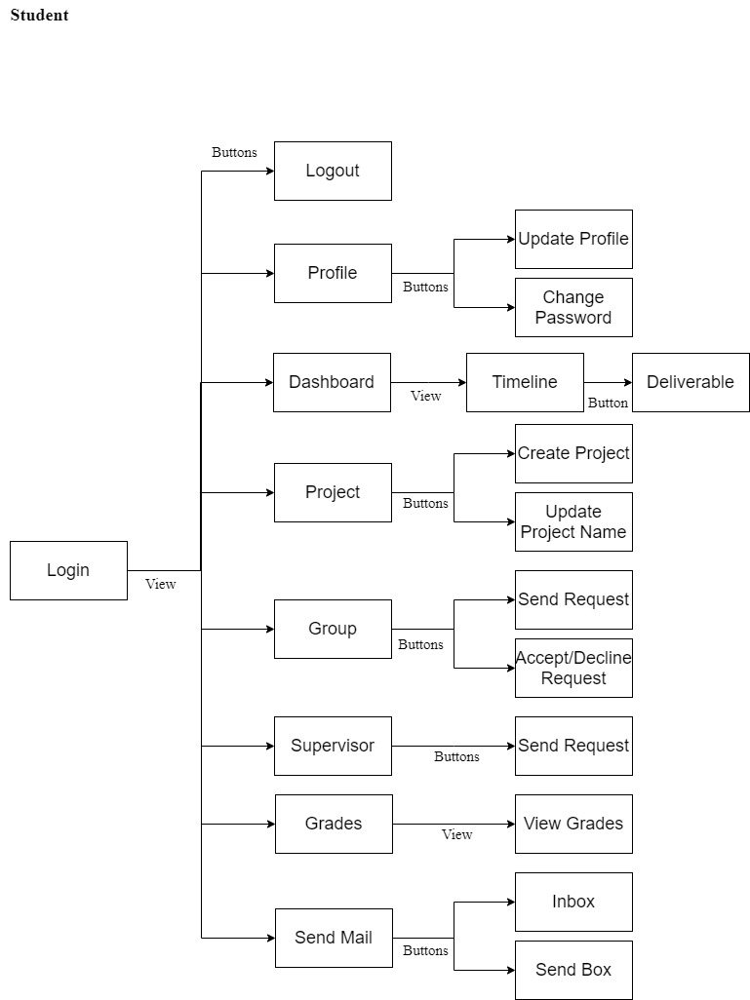
UI Diagram:

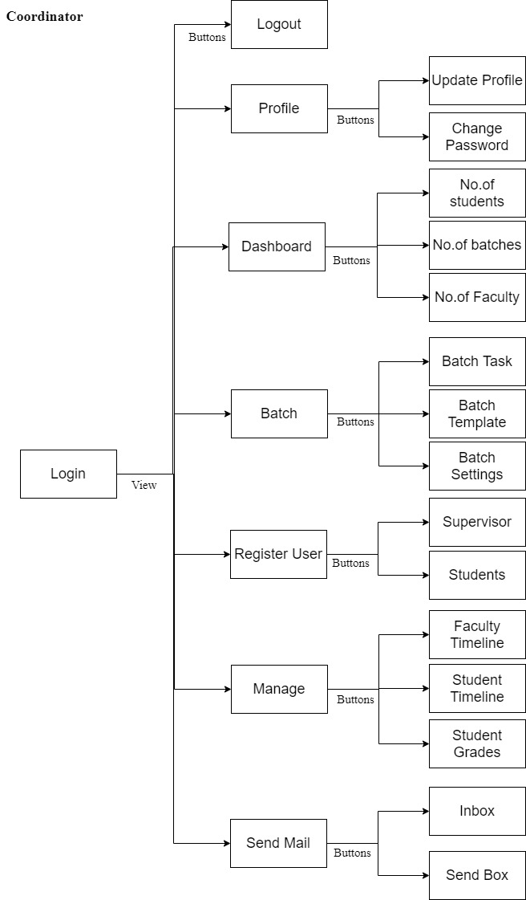

Admin:
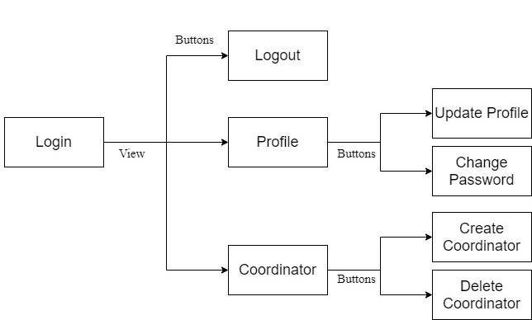

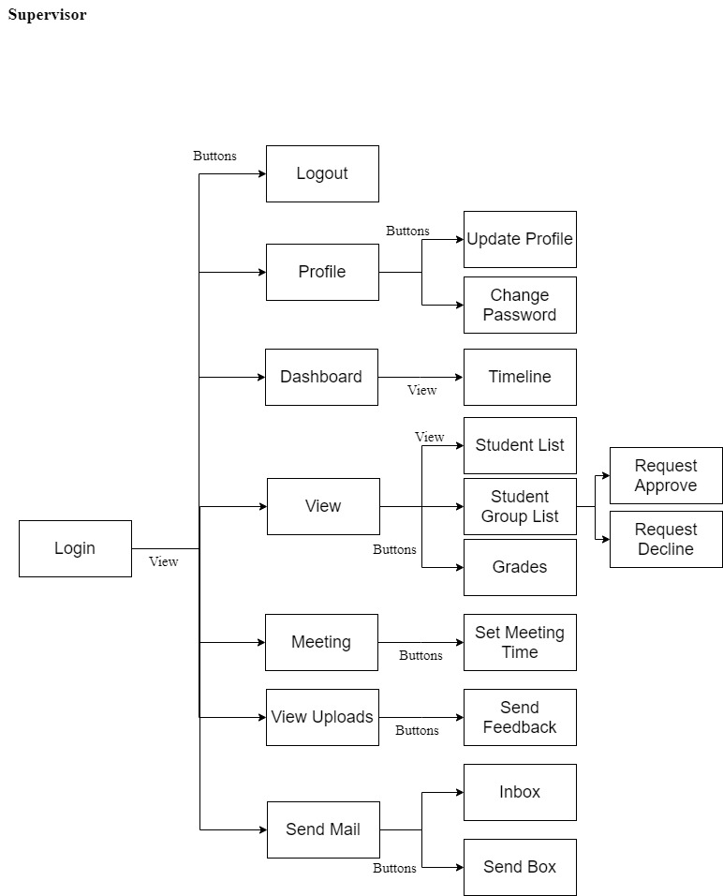

Key Milestones and Deliverables:
(Please list and describe the principal milestones and associated deliverables of the project. The timing of milestones is also to be shown in the Gantt chart in Annexure-A. Quarterly deliverables are preferred.)
S. No. | Elapsed time since start of the project | Milestone | Deliverable
1. | Week 01 – 04 | Group formation,  Selection of an Idea,  Approval of an Idea ,  Research of approved idea. | Project Proposal Form.
2. | Week 05 – 08 | Functional and non-Functional requirements | Functional and non-Functional requirements  Document.
3. | Week 09 – 12 | Use Case Diagram,  Entity relationship Diagram. | Use Case diagram and ERD document.
4. | Week 13 – 16 | Logical schema of ERD,  UI diagram. | ERD and UI Diagram.
5. | Week 17 – 20 | Login Form, Admin Dashboard,  Profile Setting, Update Profile, Change Password.  Create Coordinator and manage Coordinator. | Login and Admin Panel.
6. | Week 25 – 24 | Coordinator Dashboard.  Batch, create batch, batch task, batch template.  Register user: Student, Supervisor. | Coordinator panel.
7. | Week 25 – 28 | Manage Timeline: Student and Faculty timeline.  Grade.  View: No of students, no of batch, no of projects.  Approved project. | Coordinator panel.
8. | Week 29 – 32 | Supervisor dashboard.  Approved/delete supervised request.  Manage Meeting Log.  Manage Student Timeline.  Grade. | Supervisor Panel.
9. | Week 37 – 36 | Student Dashboard.  Student timeline.  Create Projects, update project details.  Send request group, approved/decline request.  Upload files. | Student panel.
10. | Week 37 – 40 | Email: Inbox and sent box. | Email.
(Please add more rows if required.)

2.5 Risk Analysis
(Please list the risks that may cause delays in, or prevent implementation of, the project. For each risk estimate the likelihood, likely impact/consequences on the project and steps to minimize/avoid the risk.)

Risk | Likelihood  (Low, Med, High) | Impact | Mitigation

Section – 3

3.1 Resources & Other Requirements
Project Team:
The numbers in the table below must tally with the HR Cost sheet in the Budget file.
Title / Position | Number
Team Leads
Researchers / Developers
Researcher / Development Assistants
Support Staff
Contract Staff (please specify)
Others (please specify)
Add more rows if required
Team Structure:
(Please define the team structure (organogram) and role/key responsibilities of each member. If in collaboration with another partner, the division of manpower at various locations of partners be provided.)
<paste organogram here>

Title/Position  (of each member) | Role/Key Responsibilities | Minimum Qualification Required | Expertise / Background Required | Minimum Experience Required (years)

Remarks:

1. Name & Signature of Supervisor:

2. Name & Signature of Co-Supervisor:

3. Name & Signatures of FYP Coordinator:

Annexure–A: Project Schedule / Milestone Chart

(Project schedule using MS-Project (or similar tools) with all tasks, deliverables, milestones, cost estimates, payment schedules clearly indicated are preferred.)

Example:
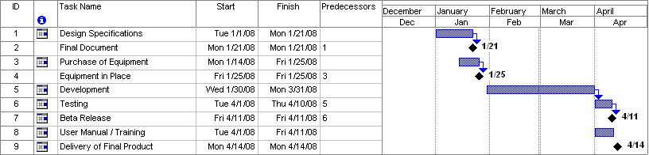
SPECIMEN

Annexure–B: Proposed Budget

Please use the embedded Excel Worksheet for providing budget details.

Double click the icon to open the worksheet.

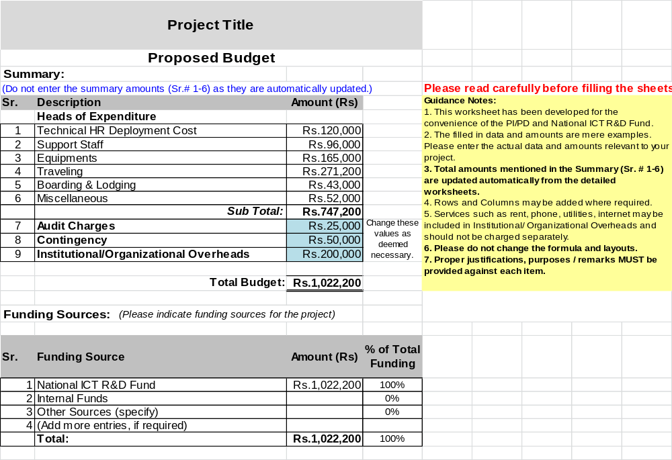

Annexure–C: Business Canvas Model

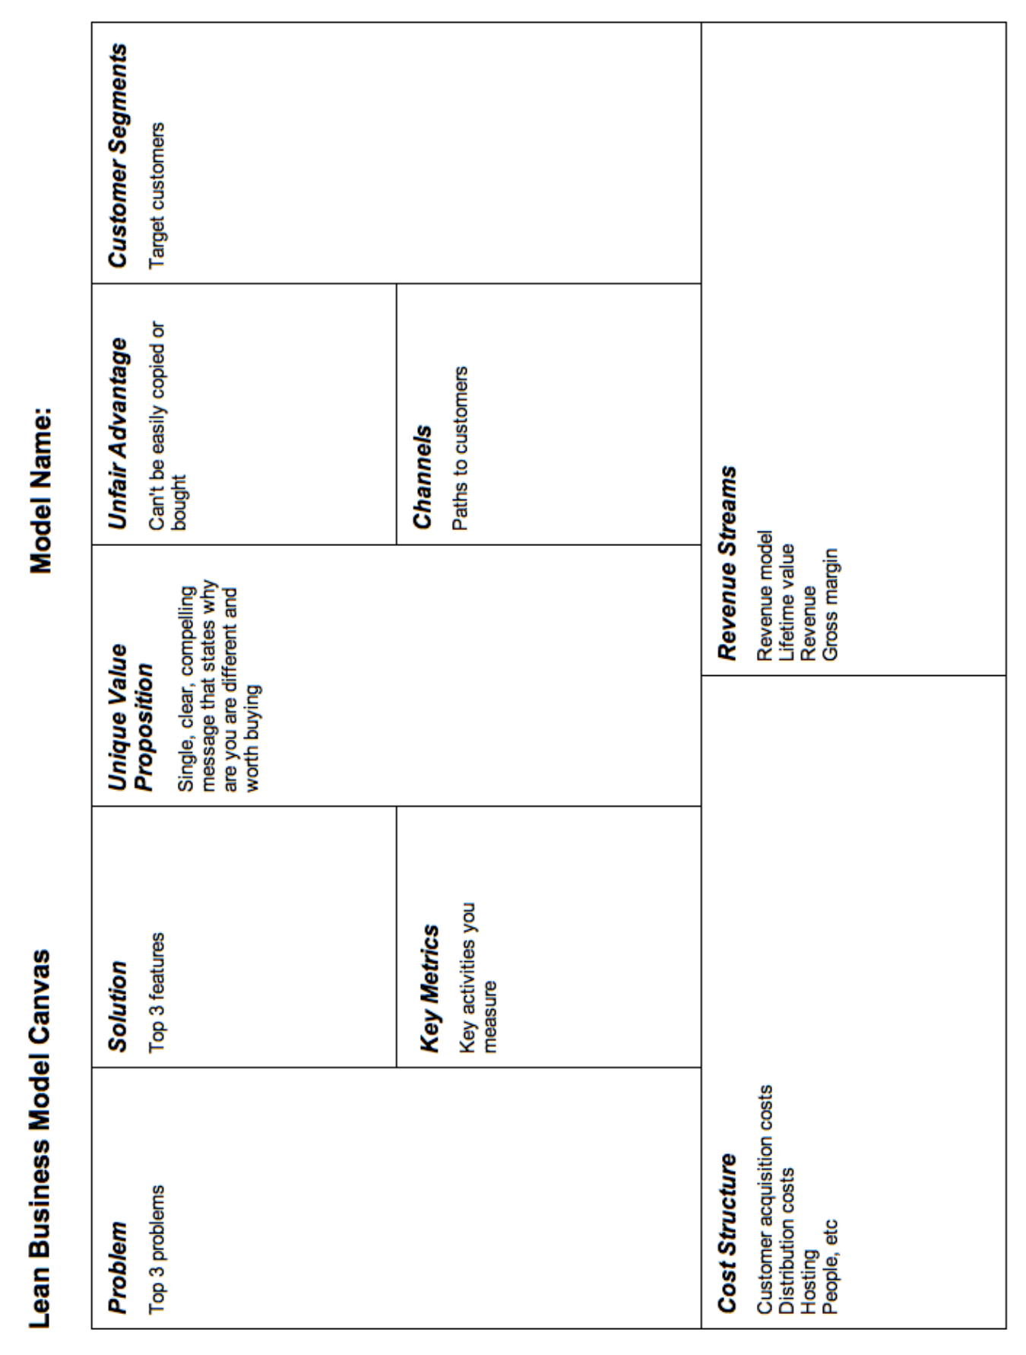

Bibliography

<type here>

